Name ________________________________________________ Date _______________

Working with Expressions

Multiplying Functions

Independent Practice

- Evaluate $g(p)∙h(p)$ by modeling or by using the distributive property.
$g\left(p\right)=(p-2)$ and $h\left(p\right)=(p^{3}+4p^{2}-2)$

- Evaluate $f(x)∙g(x)$ by modeling or by using the distributive property.
$f\left(x\right)=(-3x+2)$ and $g\left(x\right)=(2x^{2}-5x-1)$

- Jamie used the distributive property to find the product of $s(t)$ and $h(t)$. His work was marked incorrect. Identify Jamie’s mistake. What advice would you give Jamie to avoid this mistake in the future.

- The figure below shows the penalty box and the goal box of a soccer field. The penalty box is the larger rectangle.
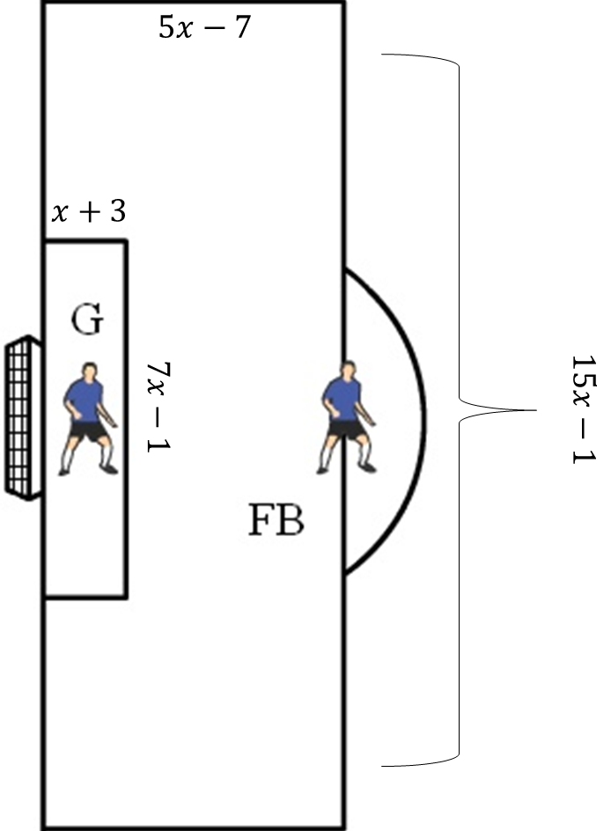

Part A: Find the area of the penalty box.

Part B: Find the area of the goal box.

Part C: Find the area of the penalty box not covered by the goal box.

