Name

Class

Date

Quadratic Functions and Transformations

**Graph each function.**

**1.** *y =* 3*x*2**2.** *f*(*x*) = −5*x*2

**3.  4. **

**Identify the vertex, axis of symmetry, the maximum or minimum value, and the domain and the range of each function.**

**5.** *y =* (*x −* 2)2 + 3 **6.** *f*(*x*) = −0.2(*x +* 3)2 + 2

**Graph each function. Identify the axis of symmetry.**

**7.** *y =* (*x +* 2)2 − 1 **8.** *y =* −4(*x −* 3)2 + 2

**Write a quadratic function to model each graph.**

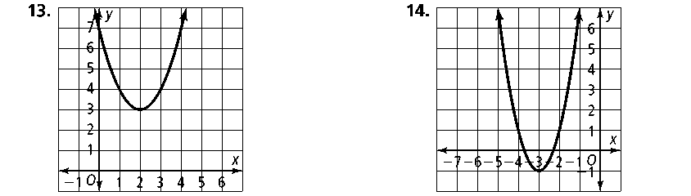 **9. 10.**

**Describe how to transform the parent function *y* =** ***x*2 to the graph of each**

**function below.**

**11.** *y =* 3(*x +* 2)2 **12.** *y =* −(*x +* 5)2 + 1

**13. ** **14.** *y =* −8(*x −* 4)2 + 12

**Write the equation of each parabola in vertex form.**

**15.** vertex (3, −2), point (2, 3) **16.** vertex , point (2, −8)

**17.** vertex (−4, −24), point (−5, −25) **18.** vertex (−12.5, 35.5), point (1, 400)

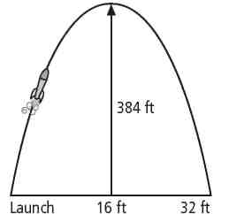**19.** The diagram shows the path of a model rocket launched from the ground. It reaches a maximum altitude of 384 ft when it is above a location 16 ft from the launch site. What quadratic function models the height of the rocket?