Name _________________ Period _______________ Date _______________
Circles whose center is not on (0,0)
For questions 1-4, match the equation with the graph.
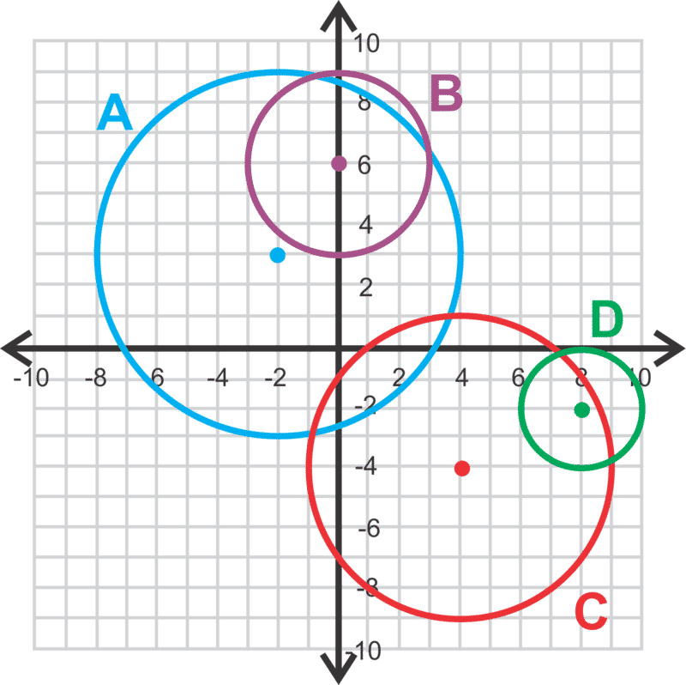
- ${\left(x-8\right)}^{2}+{\left(y+2\right)}^{2}=4$

- $x^{2}+{\left(y-6\right)}^{2}=9$

- ${\left(x+2\right)}^{2}+{\left(y-3\right)}^{2}=36$

- ${\left(x-4\right)}^{2}+{\left(y+4\right)}^{2}=25$

Graph the following circles. Find the center and radius.

- ${\left(x-2\right)}^{2}+{\left(y-5\right)}^{2}=16$

- ${\left(x+7\right)}^{2}+{\left(y-1\right)}^{2}=8$

Find the equation of the circle, given the information below.

7. center: (−3,−3) radius: 7

- center: (−7,6) radius: $\sqrt{15}$

Extra Credit: Graph each circle. (Hint: Find the radius for #9, and the center and radius for #10)

- center: (−2,−5) point on circle: (3,2)

- diameter endpoints: (−4,1) and (6,3)

