Name_______________________ Period __________________ Date ____________
DOMAIN AND RANGE
Determine if the following sets of points are functions. If so, state the domain and range.
- {(5, 6), (-1, 5), (7, -3), (0, 9)}
- {(9, 8), (-7, 8), (-7, 9), (8, 8)}
- {(6, 2), (-5, 6), (-5, 2)}
- {(-1, 2), (-6, 3), (10, 7), (8, 11)}
- {(5, 7), (3, 7), (5, 8), (8, 1)}
- {(-3, -4), (-5, -6), (1, 2), (2, -6)}
Find the domain and range of the following functions.
- y=3x−7

- 6x−2y=10

- 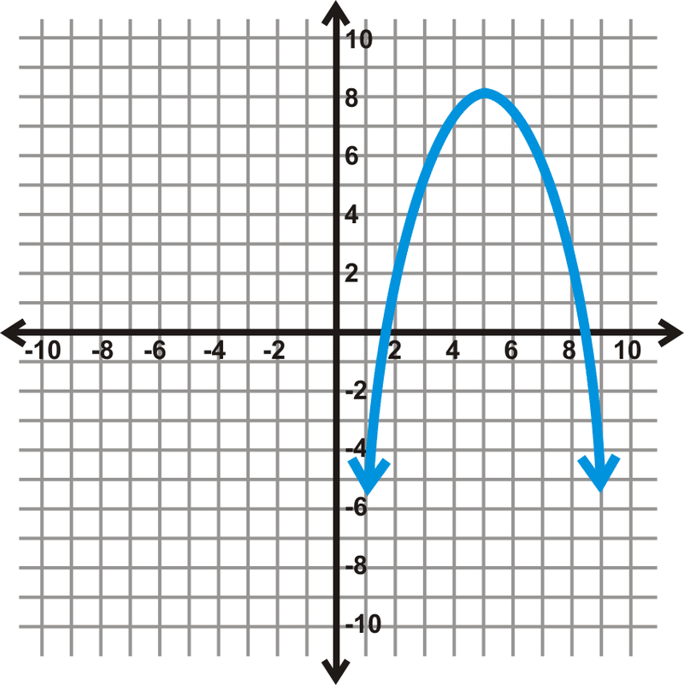
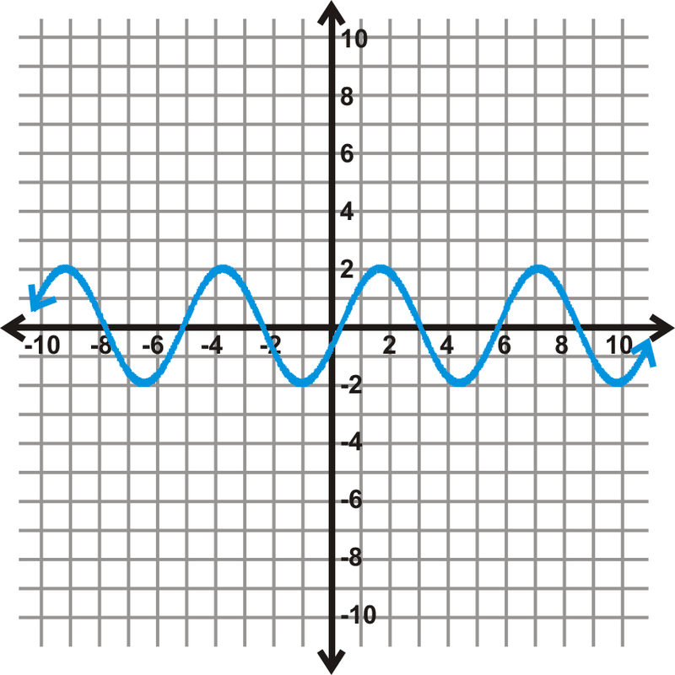

11.
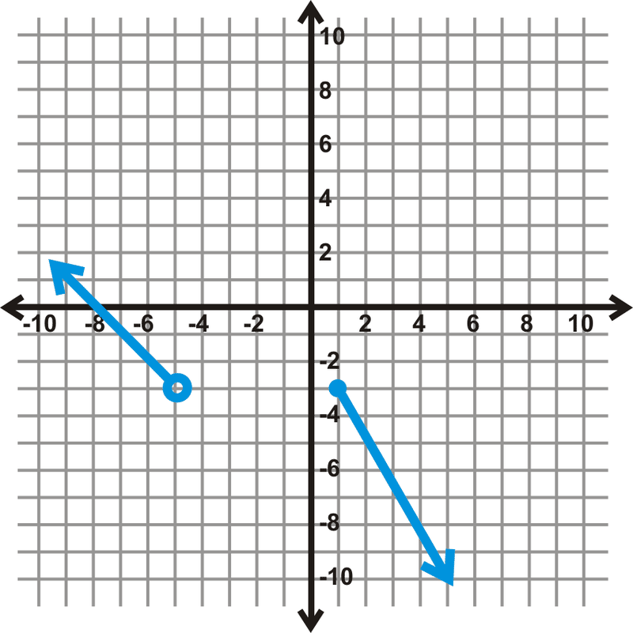

12.
