Name Date

Introduction to Functions
Key Features of Graphs of Functions – Part 1
Independent Practice

- The following statement is false. Highlight the two words that should be interchanged to make it a true statement.

In a function, every output value corresponds to exactly one input value.

- The following graph fails the vertical line test and is not a function.

- Explain how the vertical line test shows that this relation is NOT a function.

- Name two points on the graph that show that this relation is NOT a function.

- Sketch the graph of a relation that is a function.

- Sketch the graph of a relation that is NOT a function.

- Consider the following scenarios. Determine if each one represents a function or not. Explain your answer.

  - A golf ball is hit down a fairway. The golfer relates the time passed to the height of the ball.

  - A trainer takes a survey of all the athletes in a school about their height, rounded to the nearest inch, and their grade level. The trainer relates their grade levels to their heights.

- Use the word bank to complete the sentences below.

$x-$coordinate | $y-$coordinate | $x-$intercept | $y-$intercept | solution

- The ____________________ of a graph is the location where the graph crosses the $x-$axis.
- The ____________________ of a graph is the location where the graph crosses the $y-$axis.
- The ____________________ of the $y-$intercept is always zero.
- The ____________________ of the $x-$intercept is always zero.
- The $x-$intercept is the ______________ to a function or group.

- The graph below represents a rock climber’s height as she ascends a hill.

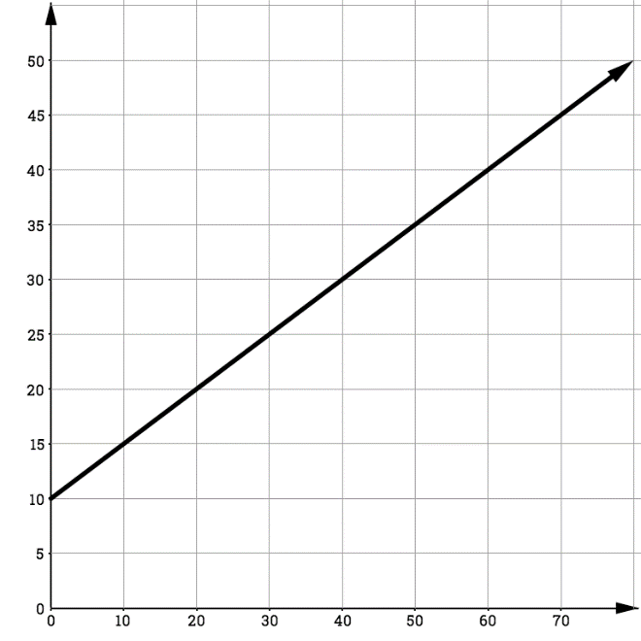
Time (s)
Elevation (ft)
Rock Climbing

- The above graph is (circle one) linear/nonlinear.

- Is the above graph a function? Explain.

- What is the $y-$intercept and what does the $y-$intercept represent?

- Why would there not be an $x-$intercept for this situation?

- The graph below represents the path of a golf ball.

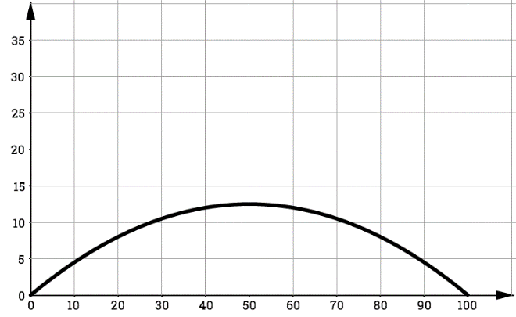
Distance (ft)
Elevation (ft)
The path of a golf ball

- The above graph is (circle one) linear/nonlinear.

- Is the above graph a function? Explain.

- What is the $y-$intercept and what does the $y-$intercept represent?

- What is the solution to this graph and what does it represent in this situation?

