Name
Class
Date

Proportions and Similar Figures
2-8

Practice Form G

The figures in each pair are similar. Identify the corresponding sides and angles.
1. 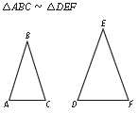 2. 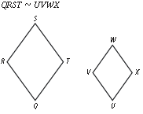
The figures in each pair are similar. Find the missing length.
3. 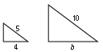 4. 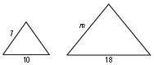
5. 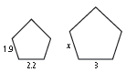 6. 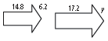
The scale of a map is 0.5 in. : 20 mi. Find the actual distance corresponding to each map distance.
7. 2 in. 8. 3.5 in. 9. 4.75 in.
- A museum has a wax sculpture of a historical village. The scale is 1.5 : 8. If the height of a hut in the sculpture is 5 feet, how tall was the original hut to the nearest whole foot?
- On a map, the length of a river is 4.75 in. The actual length of the river is 247 miles. What is the scale of the map?
Prentice Hall Gold Algebra 1 • Teaching Resources
Copyright © by Pearson Education, Inc., or its affiliates. All Rights Reserved.
73

Name
Class
Date

Proportions and Similar Figures
2-8

Practice (continued) Form G

- Sammy is constructing a model bridge out of sticks. The actual bridge is 1320 ft long. He wants the scale of his bridge to be 1 : 400. How long should the model be?
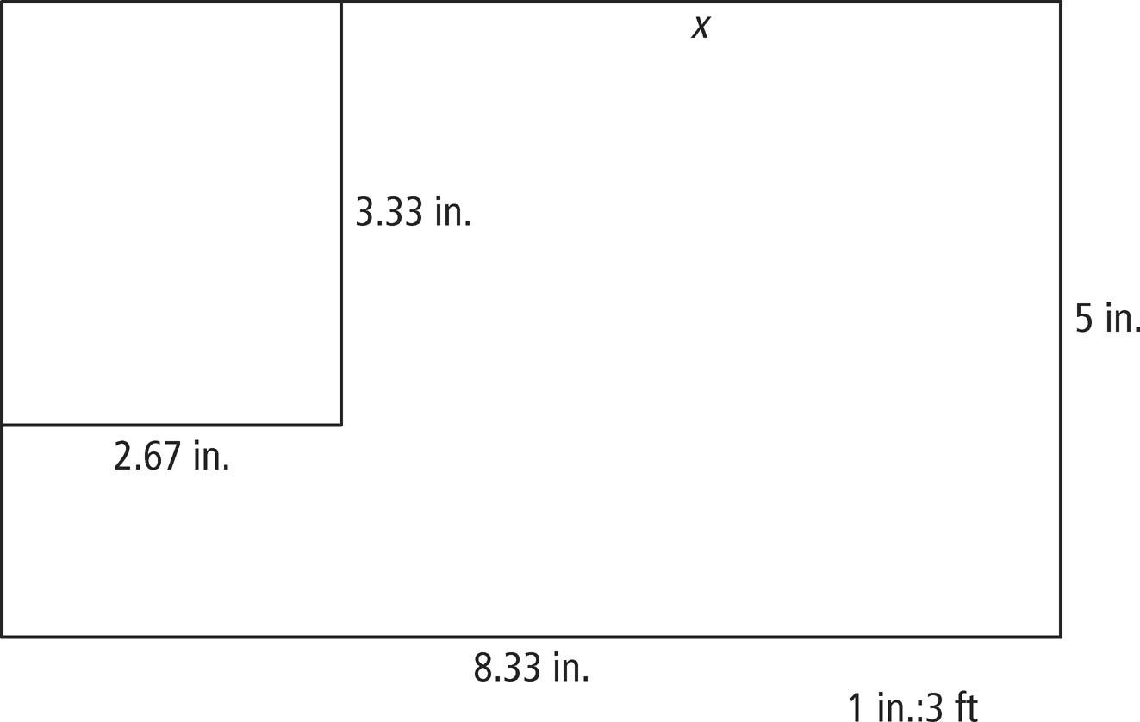
- The Finish-Line Company is drawing up plans for a room addition shown below. The addition will include a large bedroom with a bathroom as shown.
- What are the actual dimensions of the room addition?
- What are the actual dimensions of the bathroom?
- What is the actual length of the exterior wall between the end of the room
addition and the bathroom wall? This length is represented by x.
- Writing Are all right triangles similar? Explain your answer.
- Writing A pizza shop sells small 6 in. pizzas and medium 12 in. pizzas. Should the medium pizzas cost twice as much as the small pizzas because they are twice the size? Explain.
Prentice Hall Gold Algebra 1 • Teaching Resources
Copyright © by Pearson Education, Inc., or its affiliates. All Rights Reserved.
74

