Name

Class

Date



5-4

**Practice**

# Point-Slope Form

*Form G*

**Write an equation of the line in slope-intercept form through the given point and with the given slope *m*.**

**1.** (2, 1); *m* = 3 **2.** (–3, –5); *m* = –2

**3.** (−4, 11); *m=* **4.** (0, −3); 

**Graph each equation.**

**5. y**− 2 = 2(*x +* 3) **6.** *y +* 3 = –2(*x +* 1) **7. **

**Write an equation in point-slope form for each line.**

8. 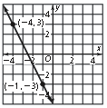 9. 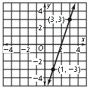 10. 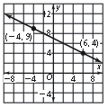

Write an equation in point-slope form of the line through the given points. Then write the equation in slope-intercept form.

**11.** (4, 0), (−2, 1) **12.** (−3, −2), (5, 3) **13.** (−5, 1), (3, 4)

**14. Open-Ended** Write an equation of a line that has a slope of  in each form.

**a.** point-slope form **b.** slope-intercept form

**Prentice Hall Gold Algebra 1 •** Teaching Resources

Copyright © by Pearson Education, Inc., or its affiliates. All Rights Reserved.

**33**

Name

Class

Date



5-4

Point-Slope Form

**Practice** (continued)

*Form G*

**Model the data in each table with a linear equation in slope-intercept form. What do the slope and *y*-intercept represent?**

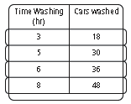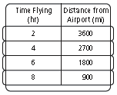15. 16.

**Graph the line that passes through the given point and has the given slope *m*.**

**17.** (−3, −4); *m =* 6 **18.** (−2, 1), *m =* −3 **19.** (−4, −2); 

1. **Writing** Describe what you know about the graph of a line represented by the equation 
2. **Writing** Describe how you would use the point-slope form to write the equation of a line that passes through the points (−1, 4) and (−3, −5) in slope-intercept form.
3. **Writing** Describe how linear data given in a table can help you write an equation of a line in slope-intercept form.
4. A sign says that 3 tickets cost $22.50 and that 7 tickets cost $52.50. Write an equation in point-slope form that represents the cost of tickets. What is the graph of the equation?

**Prentice Hall Gold Algebra 1 •** Teaching Resources

Copyright © by Pearson Education, Inc., or its affiliates. All Rights Reserved.

**34**