Name
Class
Date

Graphing Absolute Value Functions
5-8
Practice
Form G

Describe how each graph is related to y = |x|.

1. 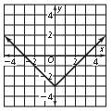 2. 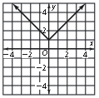
3. 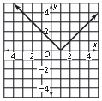 4. 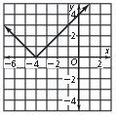

Graph each function by translating y = |x|.

5. y = |x| + 3 | 6. y = |x| − 2 | 7. y = |x| − 1.5
Write an equation for each translation of y = |x|.

8. 2 units down | 9. 1 unit up | 10. 1.18 units up
Graph each function by translating y = |x|.

11. y = |x + 6| | 12. y = |x − 5| | 13. y = |x + 3.2|
Prentice Hall Algebra 1 • Teaching Resources
Copyright © by Pearson Education, Inc., or its affiliates. All Rights Reserved.
73

Name

Class

Date

Graphing Absolute Value Functions
5-8
Practice (continued)
Form G

Write an equation for each translation of y = |x|.

14. left 7 units | 15. | 16.
At the right is the graph of y = 2|x|. Graph each function by translating y = −|x|.

17.. | y = −|x + 2| | 18. | y = −|x| − 2
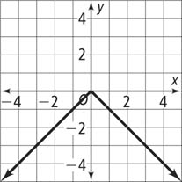

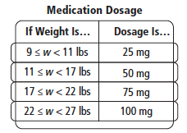
19. The table at the right shows the dosage of a certain medication for a child’s weight, w. Graph the step function for this information.

20. Reasoning Examine the expressions |m − n| and |n − m|. Substitute m = 2 and n = 3 in each expression and simplify. Now, substitute m = 3 and n = 2 in each expression and simplify. Repeat this process with 3 other sets of numbers for m and n. What is your conclusion?
21. Writing Can the absolute value of a number equal a negative number?
Explain your reasoning.
Graph each translation of y = |x|. Describe how the graph is related to the graph of y = |x|.

22. y = |x + 3| − 2 | 23. y = |x − 2| + 4
Prentice Hall Algebra 1 • Teaching Resources
Copyright © by Pearson Education, Inc., or its affiliates. All Rights Reserved.
74

