Name
Class
Date

Systems of Linear Inequalities
6-6

Practice Form G

Solve each system of inequalities by graphing.

1. 3x + y ≤ 1 | 2. 5x − y ≤ 1 | 3. 4x + 3y ≤ 1
x − y ≤ 3 | x + 3y ≤ −2 | 2x − y ≤ 2

- Writing What is the difference between the solution of a system of linear
inequalities and the solution of a system of linear equations? Explain.

- Open-Ended When can you say that there is no solution for a system of
linear inequalities? Explain your answer and show with a system and graph.

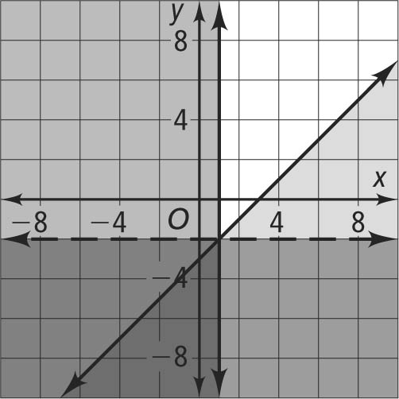
6. Error Analysis A student graphs the system below. Describe and correct the student’s error.
x − y ≥ 3
y < −2
x ≥ 1

Determine whether the ordered pair is a solution of the given system.

7. (0, 1); | 8. (–2, 3); | 9. (1, 4);
1 − x ≥ 3y | 2x + 3y > 2 | 2x + y > 3
3y − 1 > 2x | 3x + 5y > 1 | –3x − y ≤ 5
Prentice Hall Gold Algebra 1 • Teaching Resources
Copyright © by Pearson Education, Inc., or its affiliates. All Rights Reserved.
53

Name
Class
Date

6-6

Systems of Linear Inequalities
Practice (continued) Form G

- Mark is a student, and he can work for at most 20 hours a week.
He needs to earn at least $75 to cover his weekly expenses. His
dog-walking job pays $5 per hour and his job as a car wash attendant pays $4 per hour. Write a system of inequalities to
model the situation, and graph the inequalities.

- Britney wants to bake at most 10 loaves of bread for a bake sale. She wants to make banana bread that sells for $1.25 each and
nut bread that sells for $1.50 each and make at least $24 in sales. Write a system of inequalities for the given situation and graph
the inequalities.

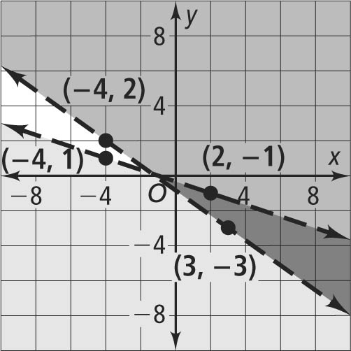
12. Write a system of inequalities for the following graph.
Solve each system of inequalities by graphing.

13. 5x + 7y > −6 | 14. x + 4y − 2 ≥ 0
x + 3y < −1 | 2x − y + 1 > 2

15.
3x + y > 2
Prentice Hall Gold Algebra 1 • Teaching Resources
Copyright © by Pearson Education, Inc., or its affiliates. All Rights Reserved.
54

