Name _______________________________________________ Date_______________________

One Variable Statistics

Measures of Spread – Part 1

Independent Practice

- Below are dot plots of the number of chocolate chips in two different store brand cookies.

Which data set has a larger standard deviation? Explain.

- Below are the most recent quiz scores from Ms. Dillon’s algebra class.

Part A: What is the median of the algebra class?

Part B: Determine the interquartile range.

- Consider the following dot plots of the salaries offered by three companies.
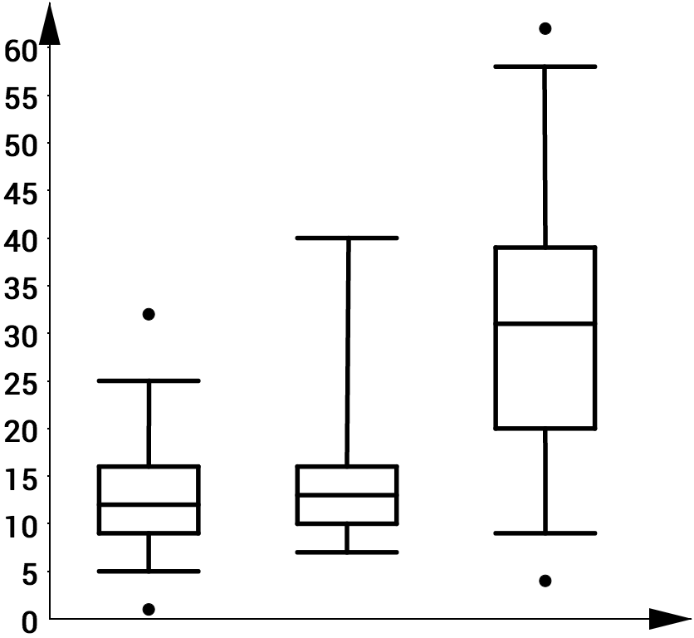
$$A$$
$$B$$
$$C$$

Part A: Which has the largest median salary?

Part B: Which has the largest IQR?

Part C: Describe the shape of each distribution (What the shape tells you about each company).

Company A:

Company B:

Company C:

